Title: Loss of large trees drives collapse of forest structure and plant biodiversity in temperate woodland

Authors: Philip Martin, Paul Evans, Elena Cantarello, Ed Mountford, Adrian Newton

Journal: Forest Ecology and Management

**Abstract**

There is widespread concern that human degradation of forests and climate change may cause transitions to treeless states. Much of the work on this topic has involved space-for-time substitution to estimate the potential effects of such drivers. In this study we make use of a 50 year time-series collected in Southern England in a forest that appears to be undergoing transition to a non-forest state, to (1) describe the patterns of the collapse; (2) the processes that appear to underlie this collapse and; (3) the consequences for plant biodiversity. Data on tree and ground flora were collected over two permanent transects on 3 or 5 separate occasions from 1964-2014. Our results indicate that while some plots maintained a stable basal area (BA), those that declined lost approximately 50% of their 1964 BA by 2014. Maps of plots suggested that plots that collapsed were more likely to be clumped together indicating the potential for a domino effect throughout the woodland. Vitally, once plots lost BA few showed signs of recovery – suggesting this system shows very low resilience. Changes in BA were principally driven by loss of large trees from the woodland. Where BA losses were greatest the community composition of woody species showed high turnover and sparse ground cover transitioned to areas dominated by grass species. These dramatic changes clearly resemble 'landscape traps' as described in previous forest studies. We speculate that in this case the trap may be caused by high mortality of large trees as a result of climatic changes and fungal pathogens, and the lack of recruitment caused by overgrazing of deer and ponies. Such potential traps are are major concern in the UK where much of the woodland is overgrazed and is facing emerging threats from new pathogens.

**Introduction**

* Human degradation, drought and other climatic changes may lead to forests transitioning to non-forest states.
* These treeless states may represent 'landscape traps' from which recovery back to forest-states may be difficult.
* Much of the work on this topic has made use of space-time analyses, making tests of resilience difficult.
* In this study we use a 50 year time-series of a previously stable woodland in Southern England parts of which appear to be undergoing transition to a treeless state.
* In this paper we aim to:
* (1) Describe the pattern of change in the woodland between 1964 and 2014.
* (2) Identify the ecological processes that might be driving the changes
* (3) Identify the consequences of these changes for plant biodiversity in the woodland

**Methods**

Site history and characteristics

* Denny wood is located in the New Forest in Southern England, was pollarded from 16th-18th centuries but from the 19th century management stopped and regeneration increased
* The woodland is largely composed of beech and oak, but also now contains areas dominated by grass that with few trees.

Data collection

* Data on trees and ground flora was collected on 3 and 5 separate occasions between 1964 and 2014 in 20x20 plots.
* Data collected in the field was supplemented with trait information taken from the PLANATT databases

Analyses

* Changes in BA, BA for particular tree size classes, species richness, community composition and grass cover relative to 1964 data were calculated and used in mixed models.
* Where proportional change data was used a response variable it was logit transformed to constrain it above a loss of 100%, or zero for community similarity
* Model selection used AICc to assess which models were 'best' and model averaging used where appropriate

**Results**

Pattern of collapse

* Plots that collapsed tended to lose ~50% of their 1964 basal area by 2014, while stable plots increased in BA by about 10%.
* Plots that lost BA seemed to be clustered and at the local scale tests suggested there was a positive correlation between plots the dataset did not show very strong spatial autocorrelation
* In plots where basal area declined it did not tend to recover, with initial decrease in BA predicting best subsequent BA and time since BA loss having low explanatory value
* The basal are change in trees with DBH >45cm showed a very strong relationship with total plot BA losses, while relationships with changes in other size classes were weak or non-existent.
* Tree species richness changes showed little correlation to collapse severity, but turnover tended to be higher in plots that collapsed.
* Ground cover species richness increased in plots that collapsed and while turnover was not constantly correlated to collapse those plots that had lost a large proportion of their basal area showed increased grass cover

**Discussion**

* In this study we show that an apparently previously stable woodland is undergoing structural collapse in some areas as a result of the loss of large trees. This loss has caused rapid turnover of the tree community and a shift to a grass dominated ground flora.

Patterns of change

* The loss of BA has not been uniform or at a similar rate for all plots, suggesting differences in
* The lack of recovery suggests this system shows poor resilience, probably as a result of reduced recruitment

Ecological drivers of change

* The loss has largely been driven by death of large trees, as seen in other part of the globe

Consequences for biodiversity

* Changes in forest structure clearly affected the tree community and lead to more open grassy areas, that may represent 'landscape traps.'
* Coupled with grazing this the loss of large trees can lead to woodlands losing all tree cover with dramatic changes in biodiversity and ES.

In the context of resilience

* This site is clearly in a state of dramatic change but it is not undergoing a regime shift as defined by Carpenter etc since the pressures apparently holding the woodland in a treeless state are constant (e.g. Grazing).
* However, regardless of whether this is a regime shift it is important since many other forests throughout the world appear to be undergoing similar changes.
* It may be difficult to restore such sites once they become heavily degraded

**Conclusion**

Figure 1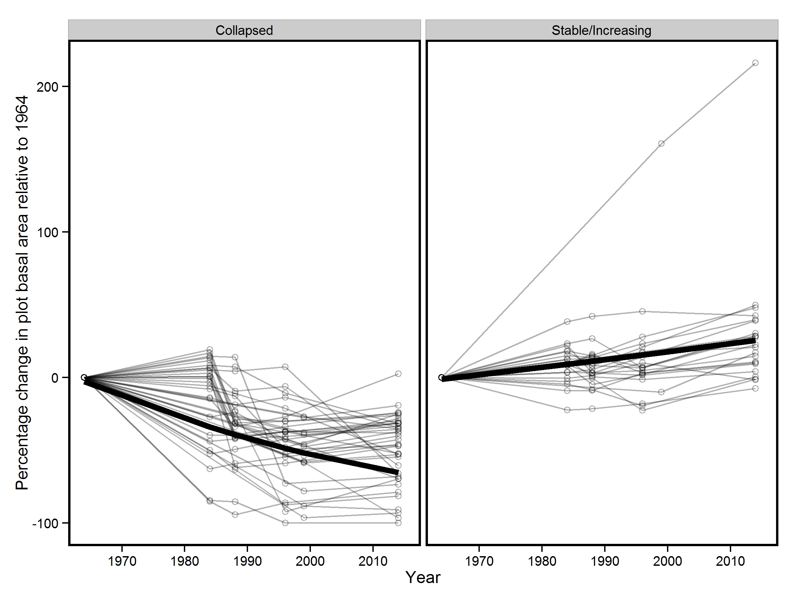

Figure 2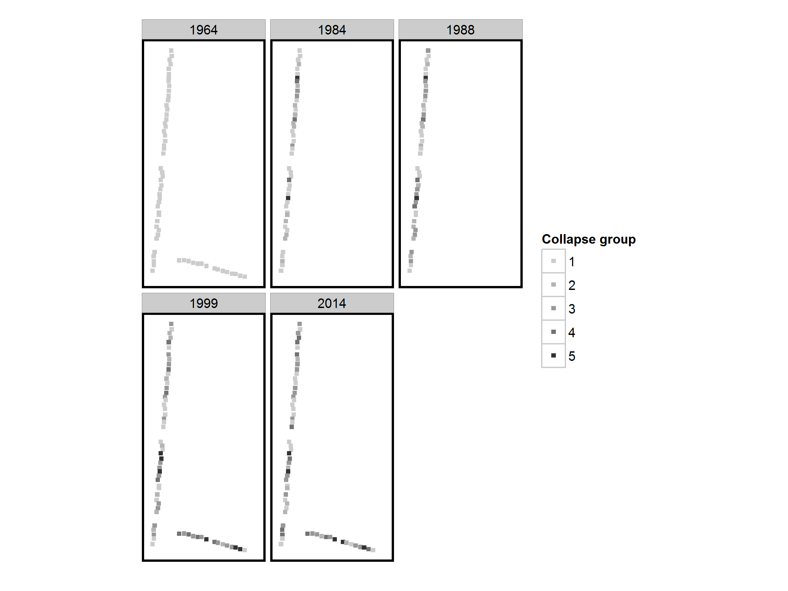

Figure 3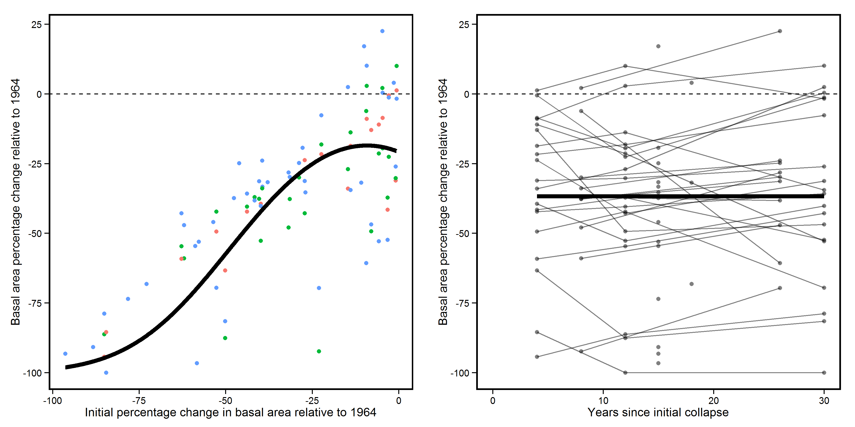

Figure 4